**Lab 1 Report**

**Team Members:**

**Chakradhar Chinnam: 03**

**Venkata Sivaram Pabolu: 17**

**Aditya Velugula: 27**

**INTRODUCTION:**

In this report we will apply some basic concepts of Python and machine learning algorithms to solve some problems.

**OBJECTIVE:**

Our goal is to utilize a few ideas of Python, for example, Dictionaries, Lists, Tuple, OOP's idea, web rejecting and so on to tackle a portion of the issues. Additionally we will apply AI ideas, for example, arrangement, relapse, bunching and so on .and will draw helpful bits of knowledge from information. Utilizing above given ideas in Python and profound learning we will fathom given assignments:

1. Given a collection of integers that might contain duplicates, nums, return all possible subsets. Do not include null subset.Example:Input: [1,2,2]Output: [ [1], [2], [1,2], [2,2], [1,2,2] ]
2. Concatenate two dictionaries and sort the concatenated dictionary by value.
3. Write a python program to create following management systems:
   * Airline Booking Reservation System
   * Library Management System
4. Use Beautiful Soap to find comparison of the clustering algorithms from web page (<https://scikit-learn.org/stable/modules/clustering.html#clustering>)
5. Perform three classification algorithms Naïve Bayes, SVM and KNN on any dataset.
6. Apply K-means on the dataset and report which K is the best using the elbow method.
7. Write a program in which take an Input file, use the simple approach to summarize a text file, read the data, tokenize the text into words and apply lemmatization technique on each word, find all the trigrams for the words, extract the top 10 of the most repeated trigrams based on their count, find all the sentences with the most repeated trigrams, extract those sentences and concatenate and print the concatenated result.
8. Create Multiple Regression by choosing a dataset of your choice. Evaluate the model using RMSE and R2.

**TASKS**

**1. Find the longest substring without repeating characters**

* Dynamic data – Input the string
* Use 'findLongestSubstring' function.
* This checks the length of string.
* Perform the checks with all the subsequent words and display the final output(If there is a repetitive word, add it to the list).

**Input snapshot:**

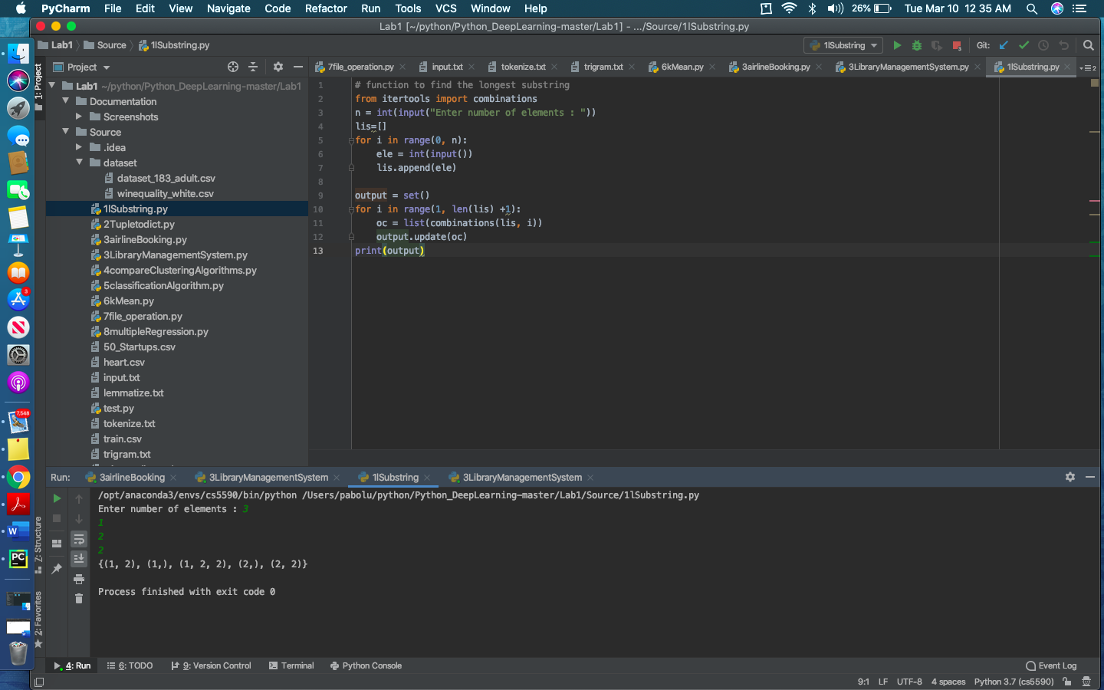

**Output snapshot:**

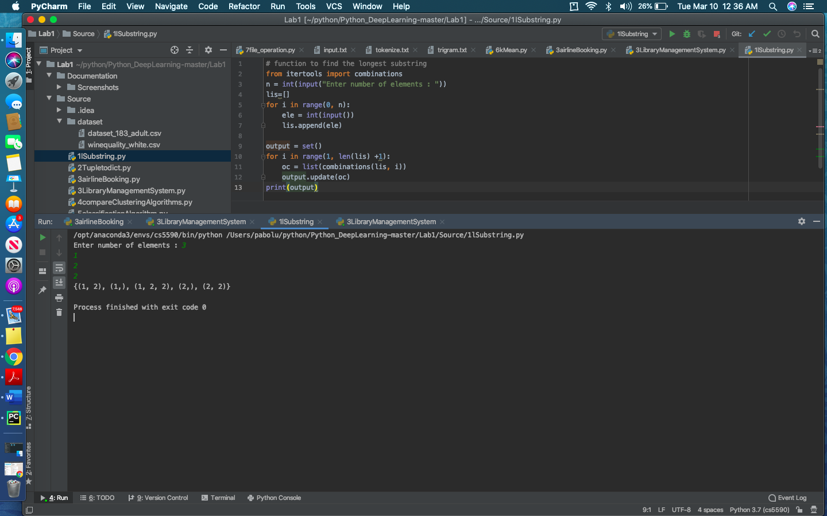

**2. Two dictionaries needs to be concatenated.**

* The data is directly given in the code.
* Dictionaries come into picture here.
* Store the values into a dictionary
* Concatenate and display the output.

**Input snapshot:**

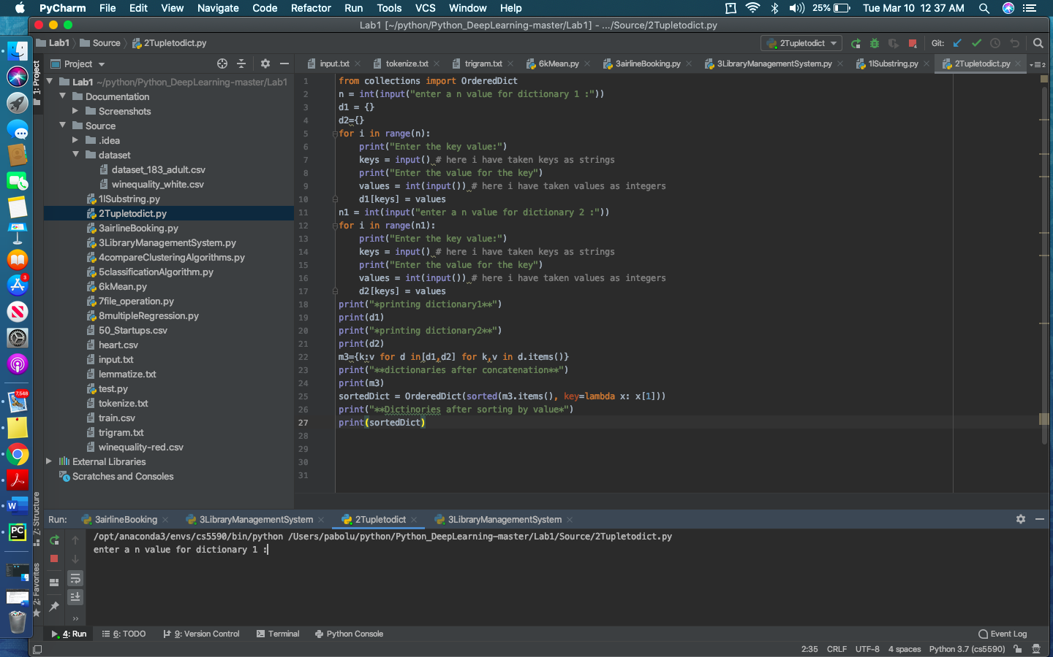

**Output snapshot:**

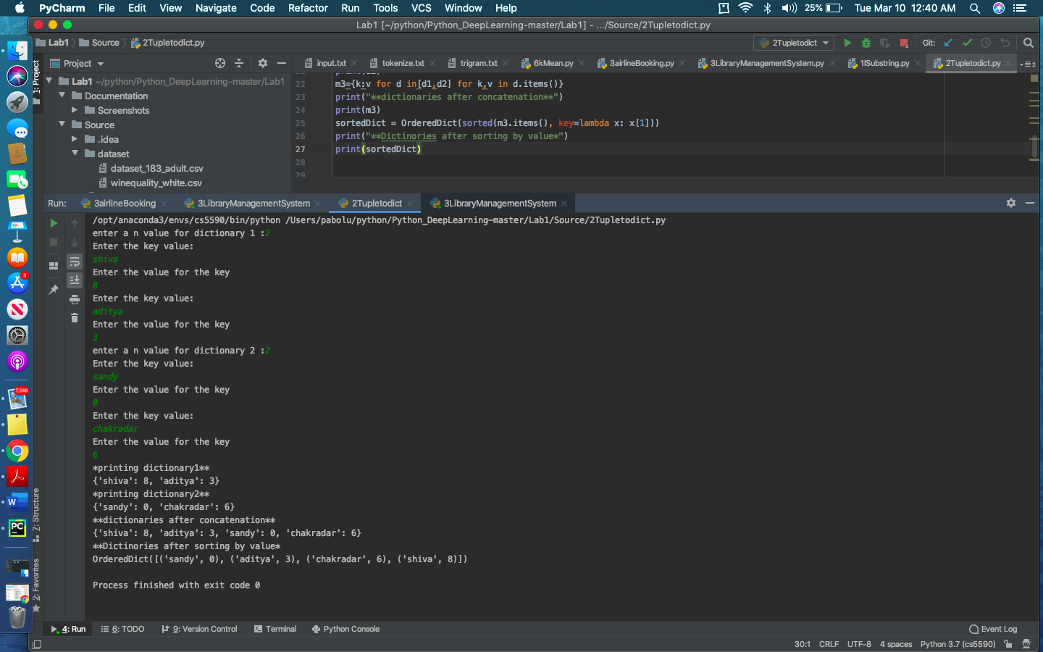

**3. Write a python program to create following management systems:**

**Airline Booking Reservation System**

* Created following classes: flight, employee, passenger, baggage, fare and ticket.
* Passenger class will take input from user through console.
* Baggage class will act as the parent class for Fare class to calculate cost of ticket.
* Cost is fixed if purchasing at counter and varies if buying it online using random function.
* Using multiple inheritance concept ticket class will inherit properties of both Passenger and Fare class will calculate final cost for passenger's ticket.

**Input Snapshot:**

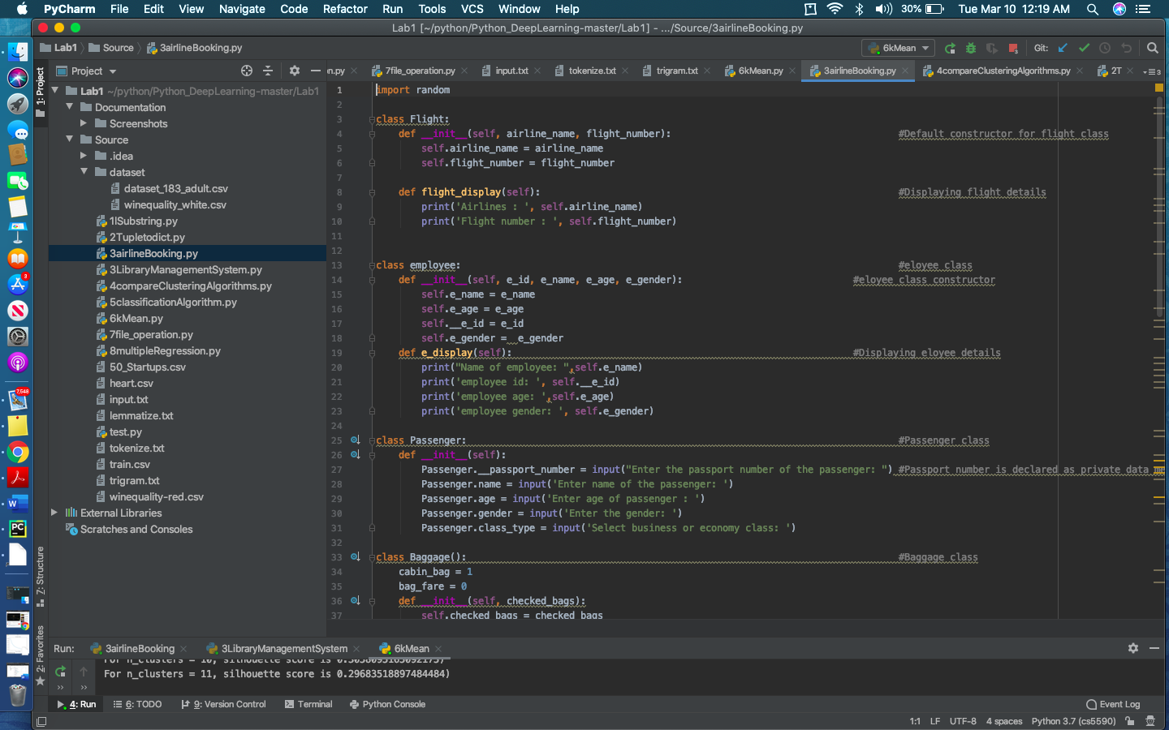

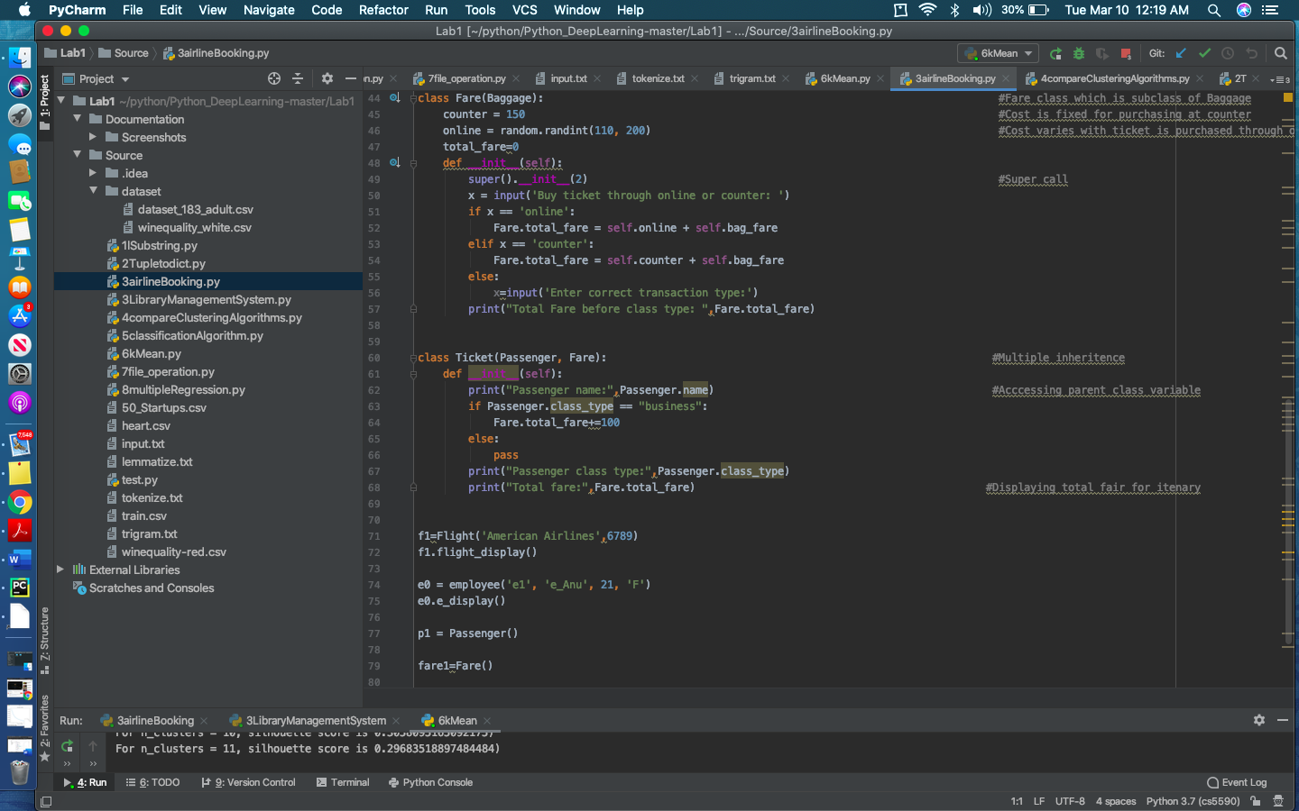

**Output Snapshot:**

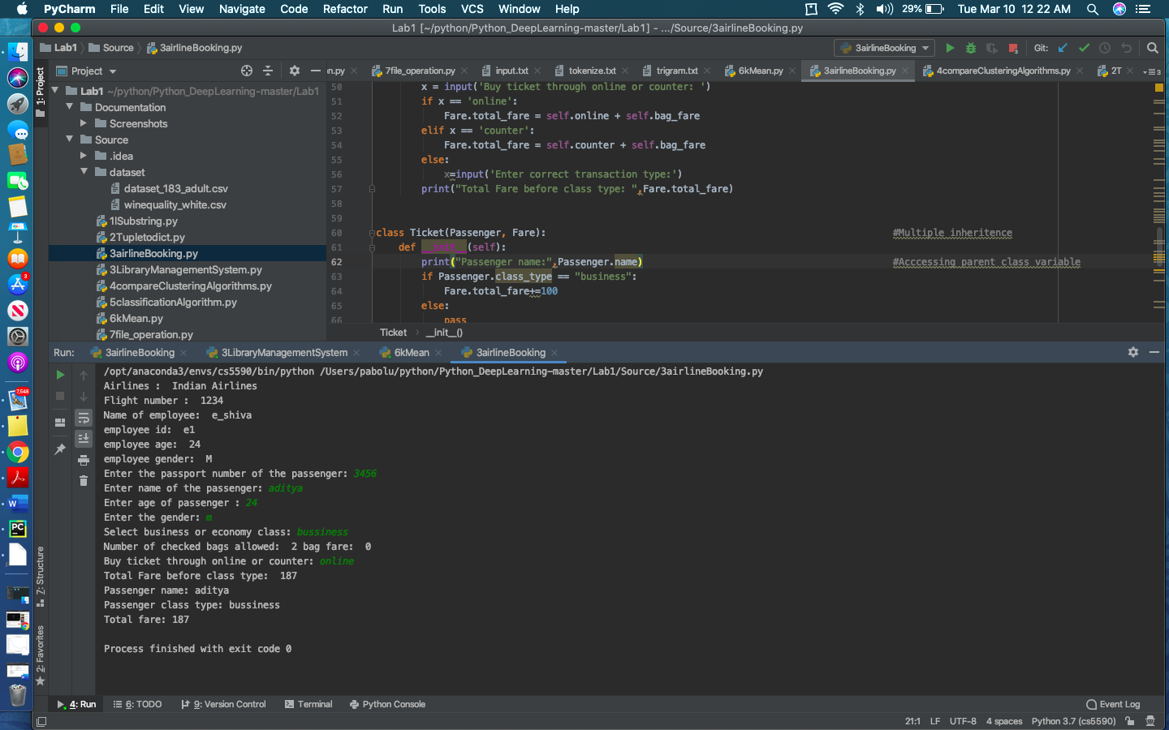

**Library Management System**

* Created various classes for Student, Library, Faculty.
* Initialized and validated the user information.
* Post validation, display the options to redirect the functionality of the library.

**Input snapshot:**

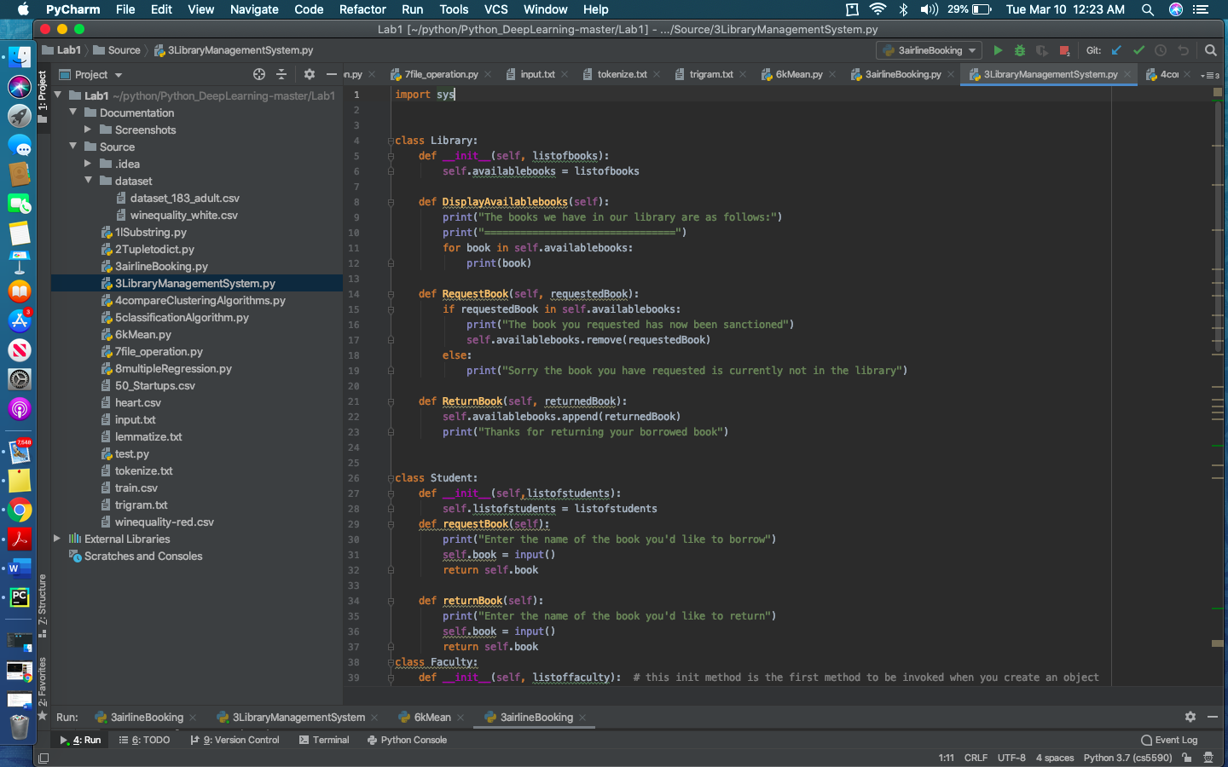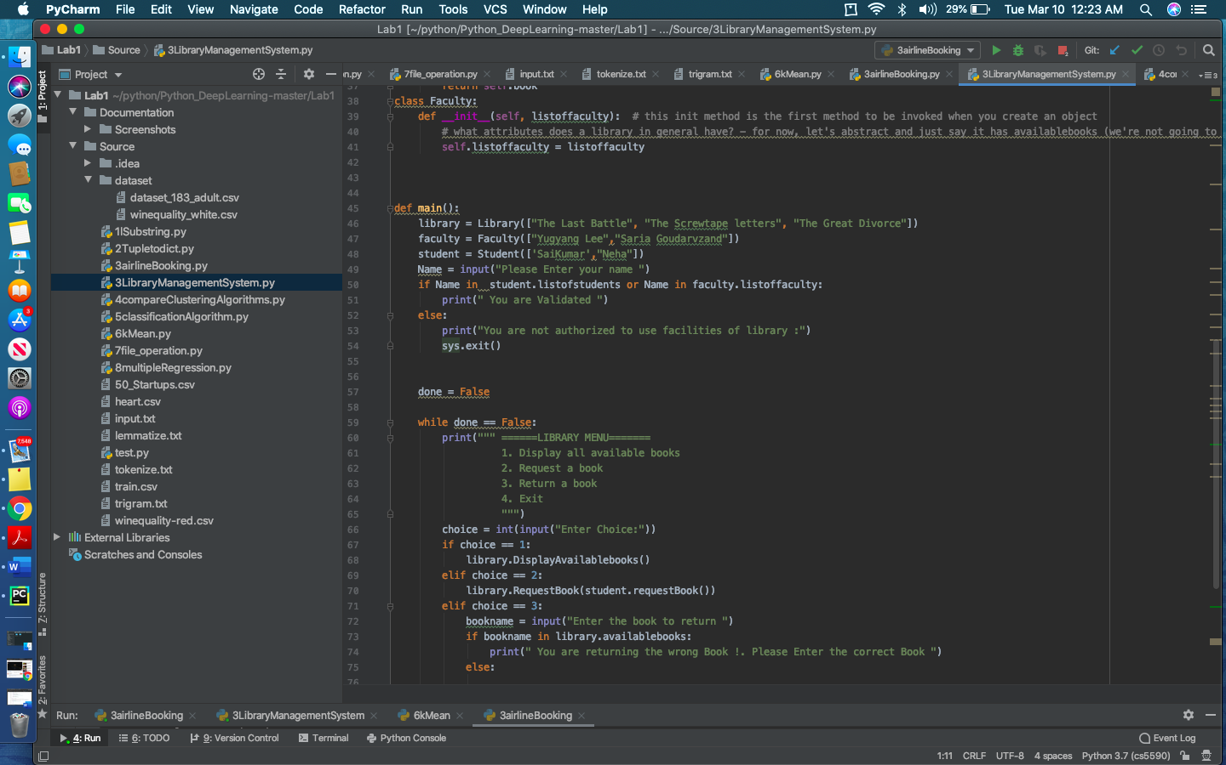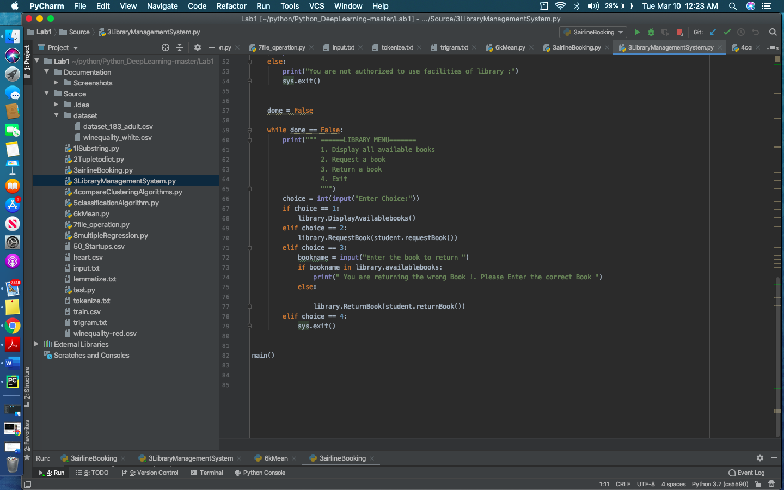

**Output snapshot:**

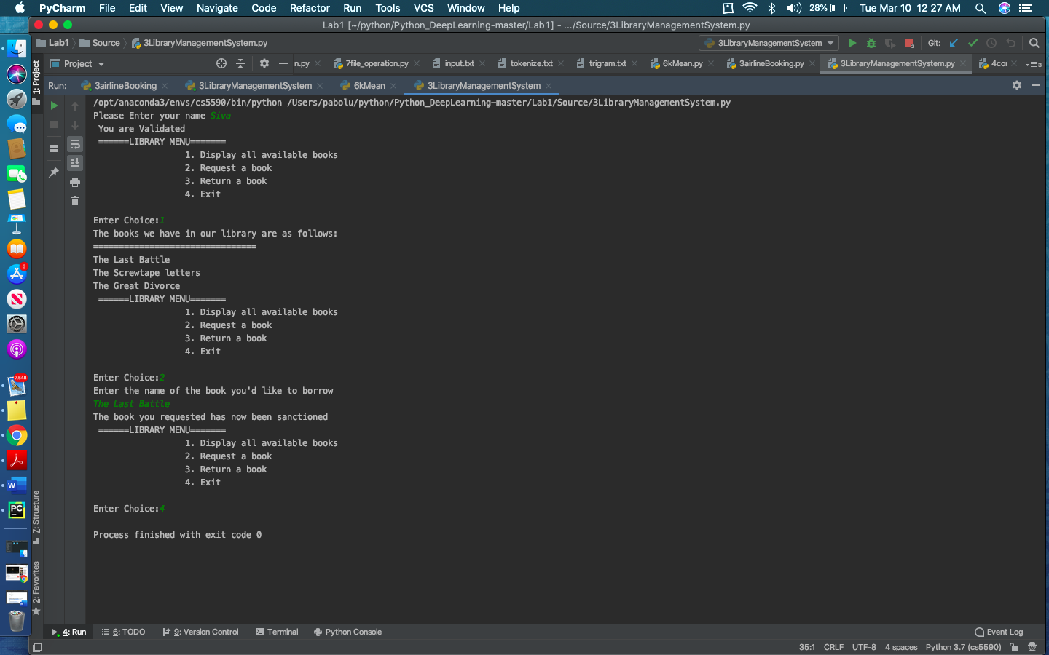

**4. Using Beautiful Soap, find the comparison of the clustering algorithms (**[**https://scikit-learn.org/stable/modules/clustering.html#clustering**](https://scikit-learn.org/stable/modules/clustering.html#clustering)**)**

* Retrieve the html from the link: <https://scikit-learn.org/stable/modules/clustering.html#clustering>
* Imported all the libraries.
* Using the 'table' tag, retrieve all the table info
* Using 'thead' tag , retrive all the headings
* Finally, save the output in the .csv file.

**Input snapshot:**

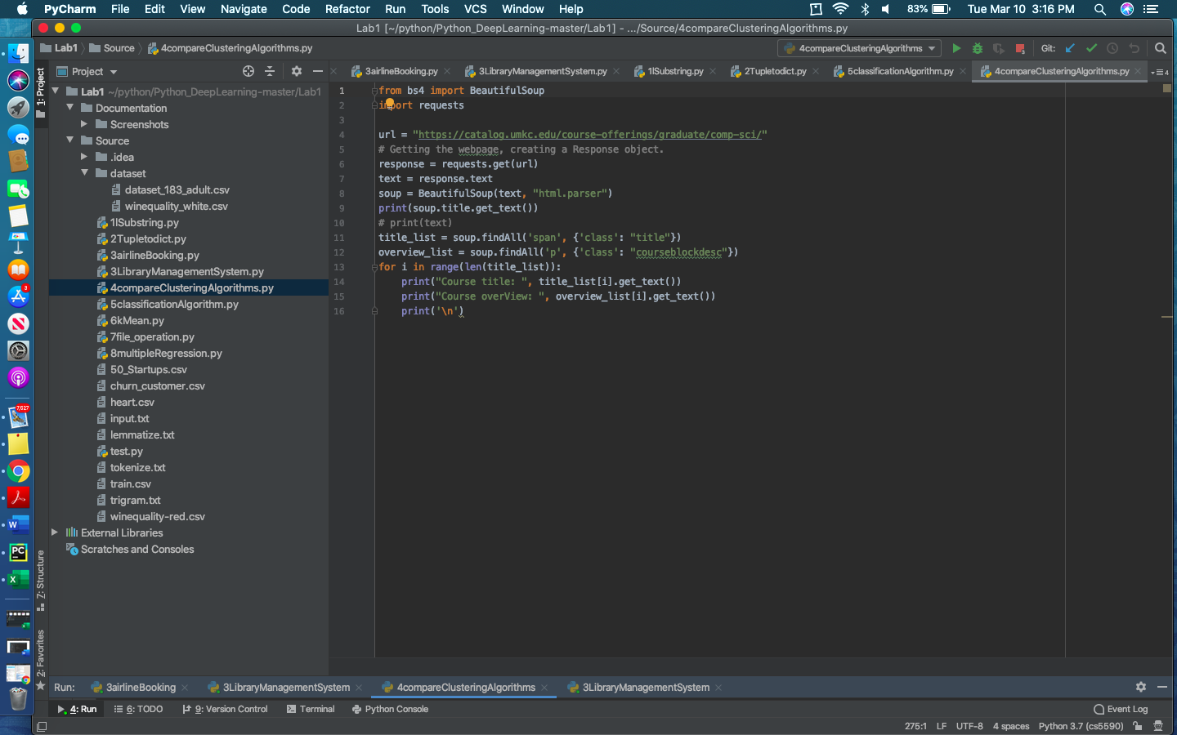

**Output snapshot:**

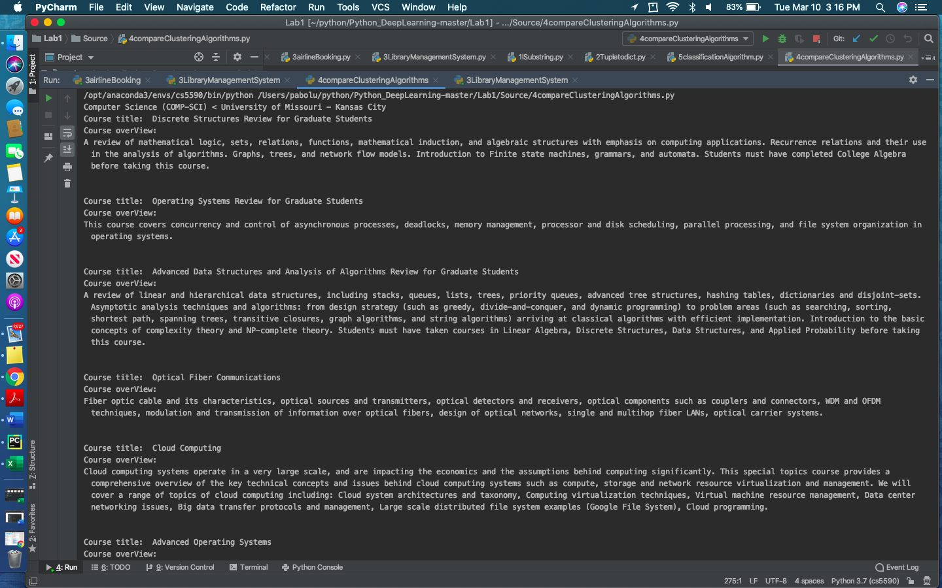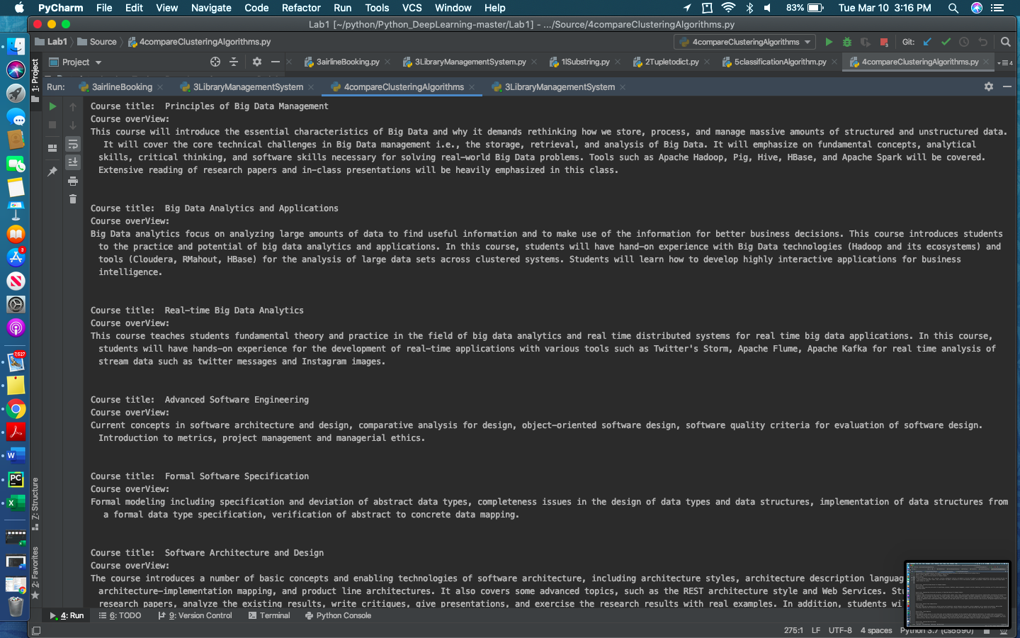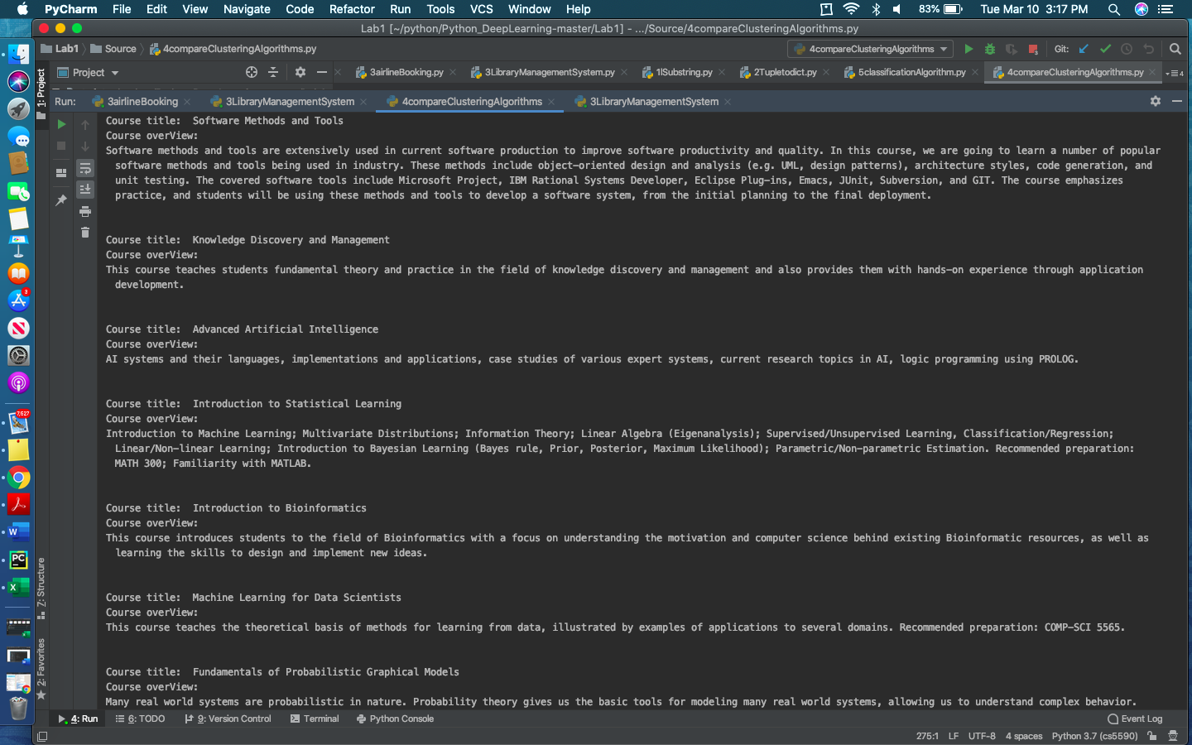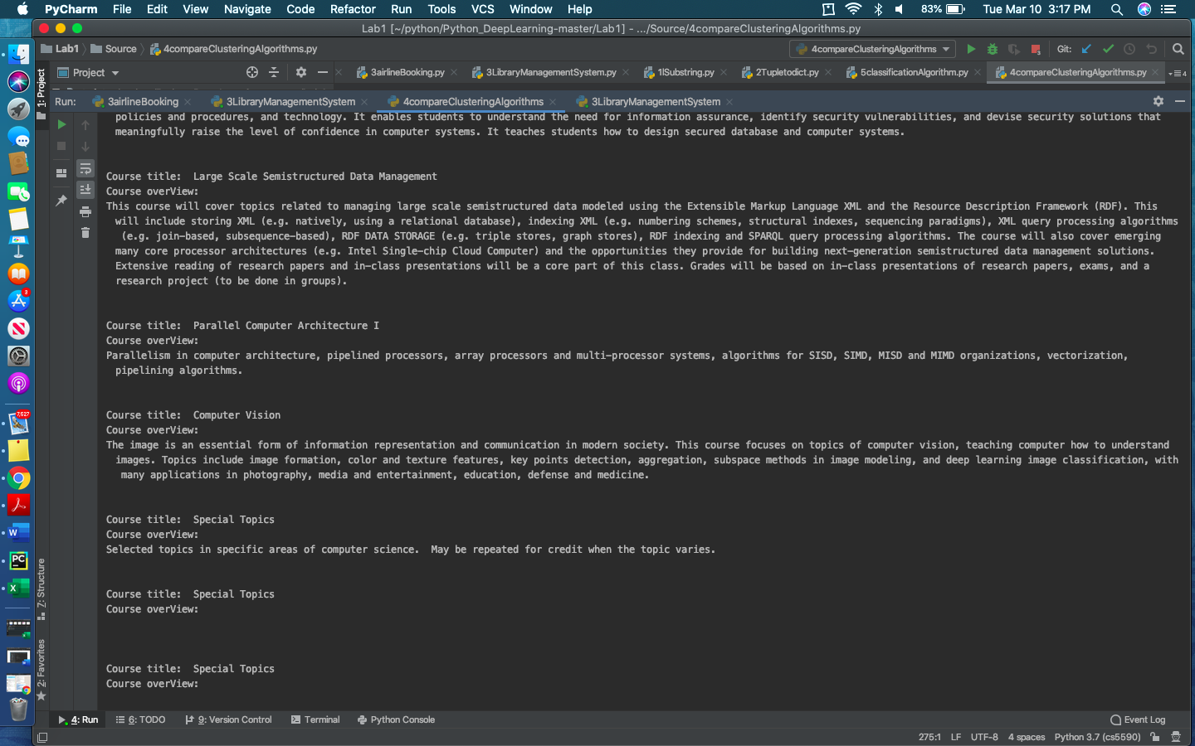

**5. 3 classification algorithms Naïve Bayes, SVM and KNN on any dataset.**

* In order to predict the income that exceeds $50K/yr ,we have taken the adult dataset (<https://archive.ics.uci.edu/ml/datasets/Adult>.)
* Retrieved the variables (training features)
* Ensured to handle the missing values. In the dataset we found 0 missing values.
* The data is divided into Test and Training data.
* Trained the model by applying three classification methods ('Naive Bayes', SVM and KNN) and find the score by passing the test data to trained model
* KNN .74 is the KNN score.
* 1 is the SVM score.
* .76 is the Naïve bayes score.

**Input Snapshot:**

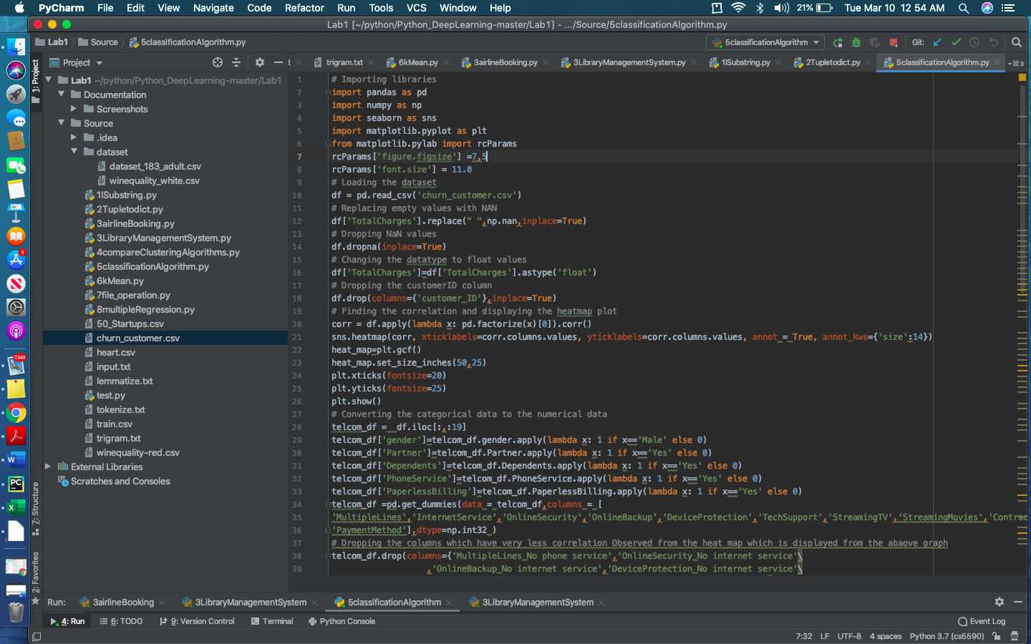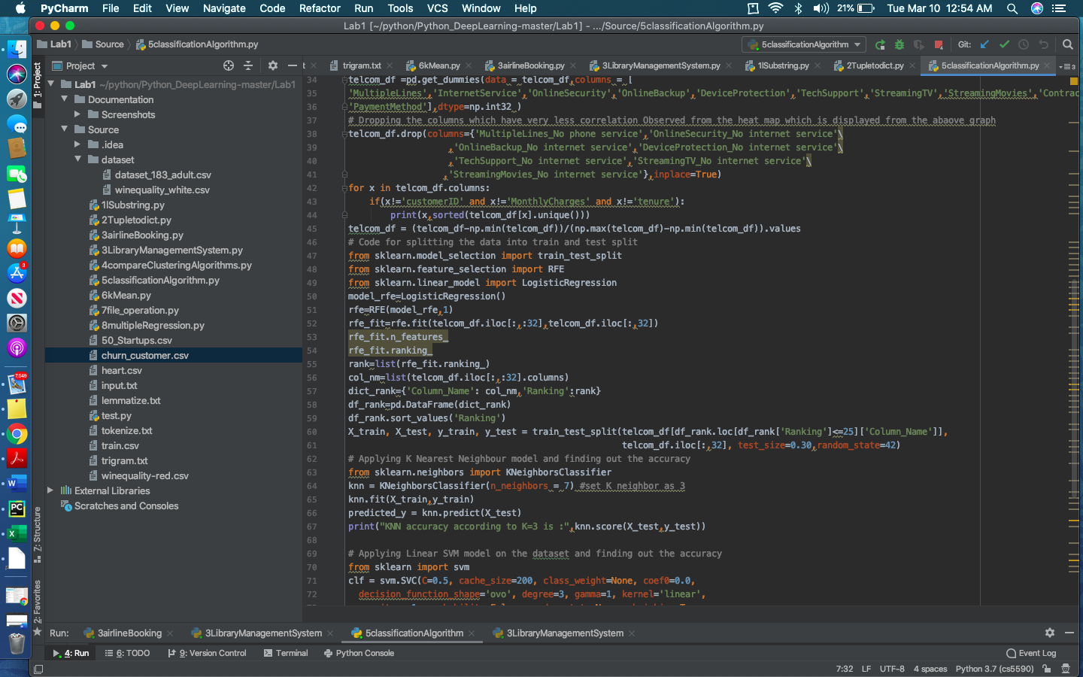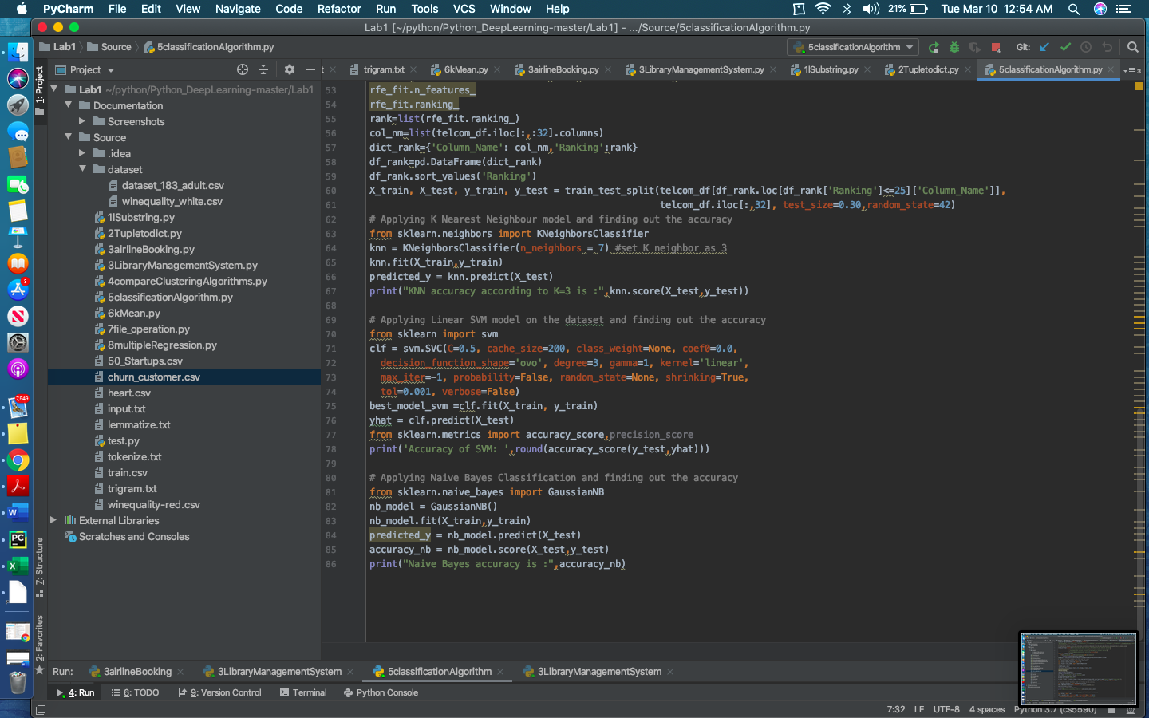

**Output Snapshot:**

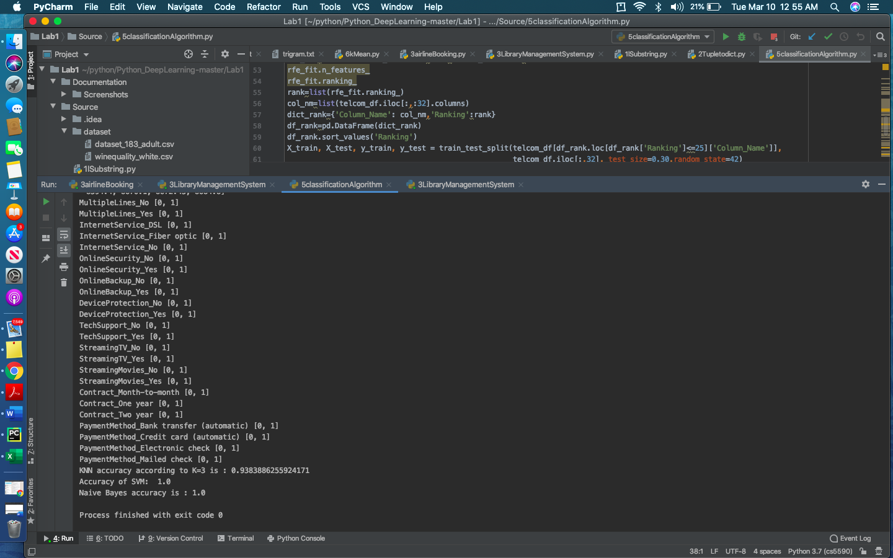

**6. Using the elbow method, report the best K after applying K-means on the dataset.**

* Inorder to find the quality wines, taken the winequality_white dataset: <https://www.kaggle.com/maitree/wine-quality-selection#winequality-white.csv>
* Ensured to handle the null values.
* Identify the most connected highlights
* Data is processed.
* The number of clusters in the data set are 2 (used the elbow method)

**Input Snapshot:**

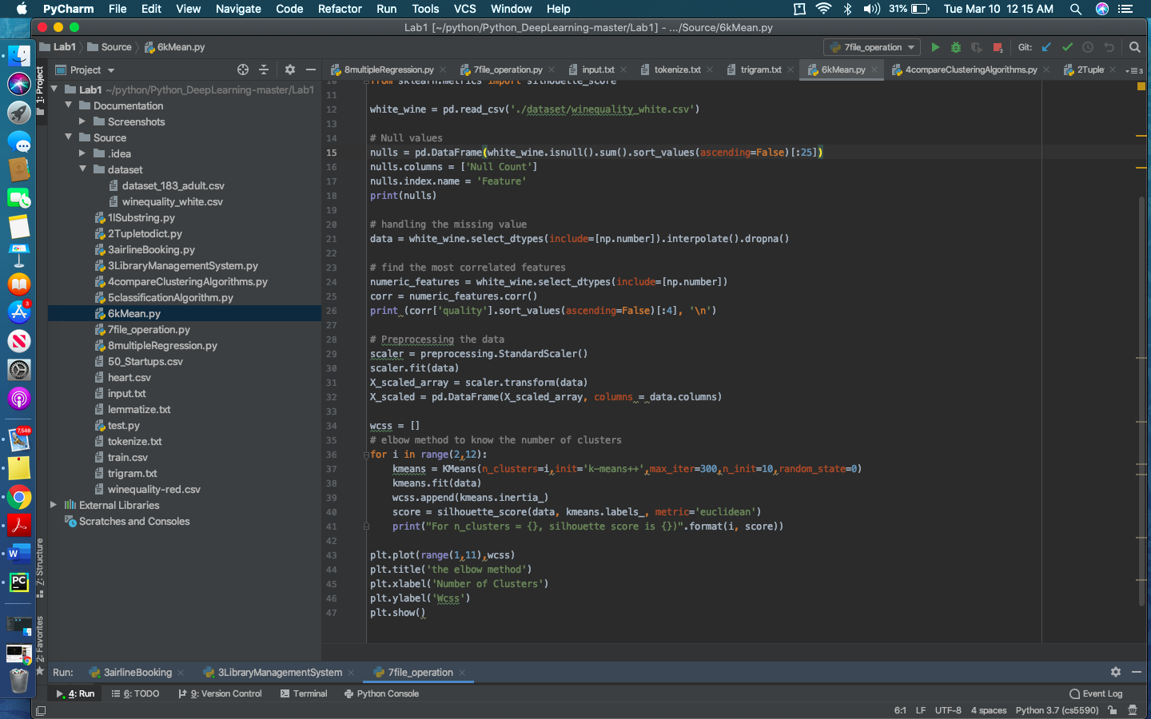

**Output snapshot:**

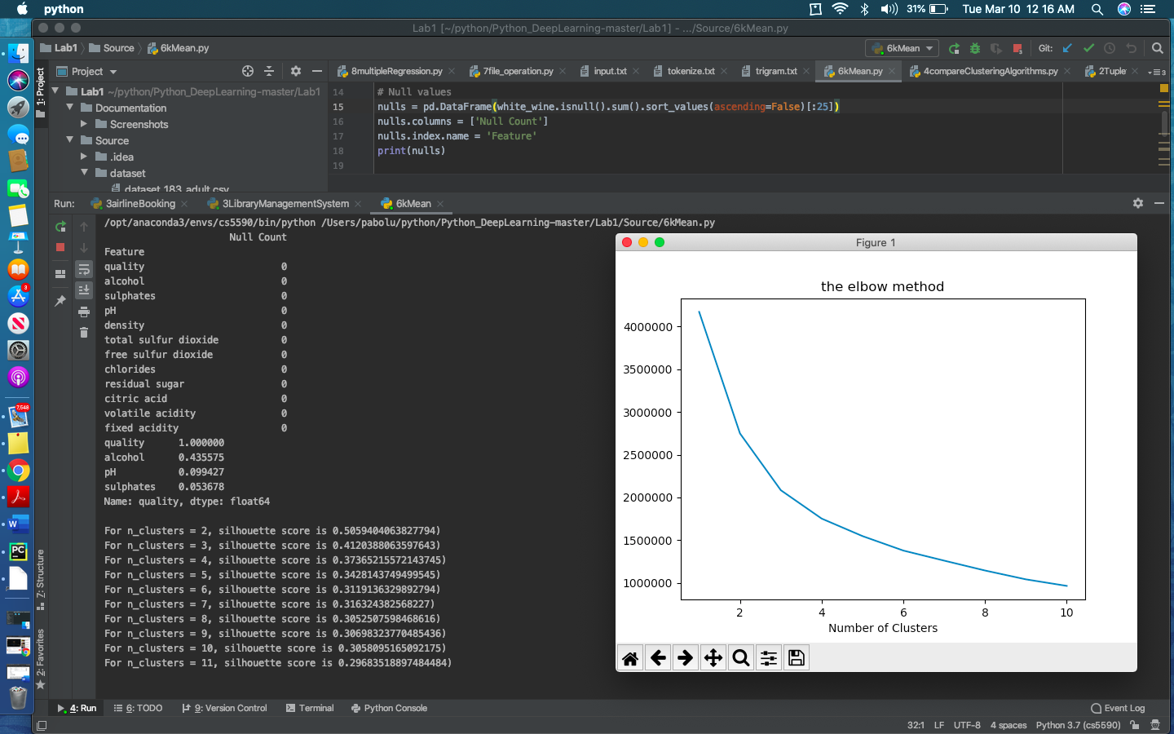

**7. Tokenization, lemmatization of the words**

**Course of Action:**

* The text record is read as input.
* Using the tokenize() method ,the text is divided into tokens and saved it in .txt file.
* Using the wordnetlemmatizer() function from natural language processing toolkit to split the words according to parts of speech and stored it in lemmatize txt file.
* Performed trigram and split the sentences to the groups of 3 words and put away it in trigram text file.
* Checked the frequency of trigrams and counted the occurrence, based on count we fetched the top 10 most repeated trigram.
* We took the most repeated trigram and found its occurrence in each sentence by iterating through the sentence and Concatenated the outcome and showed it.

**Input snapshot:**

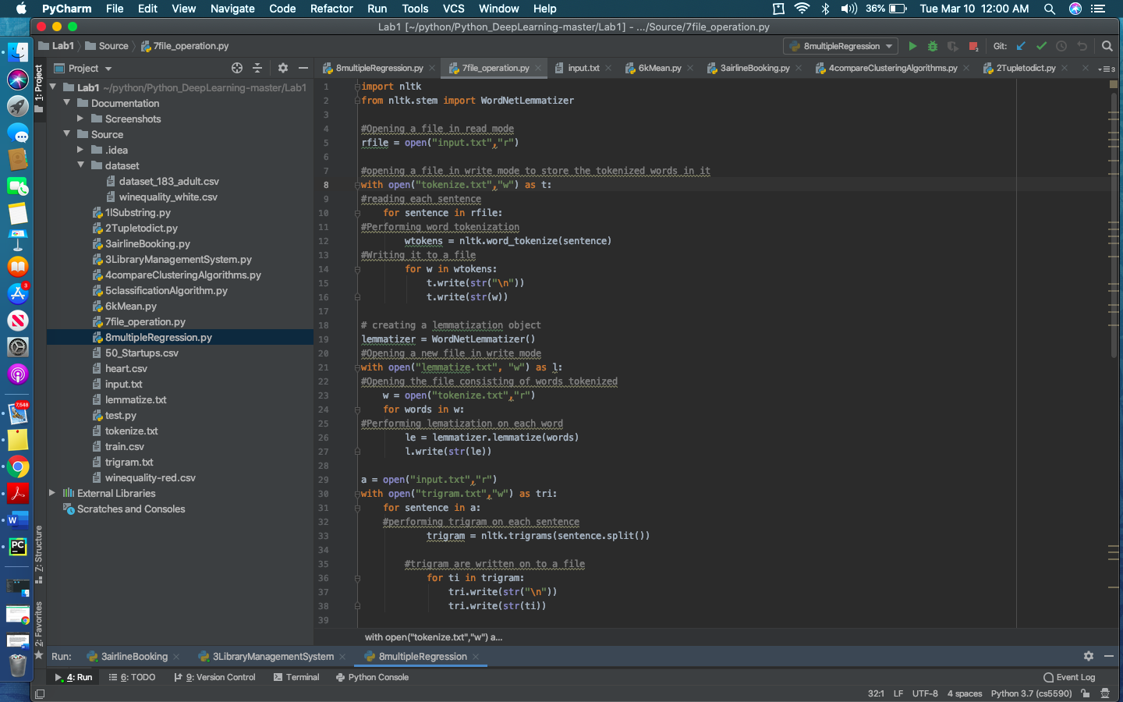

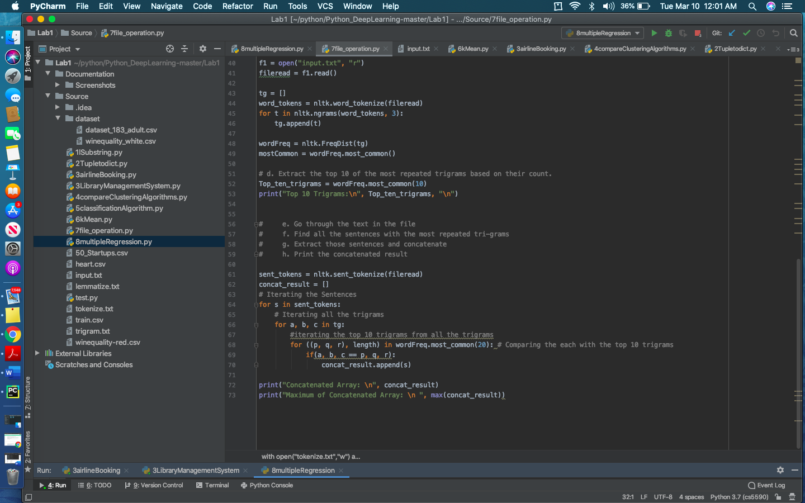

**Output snapshot:**

Input Text:

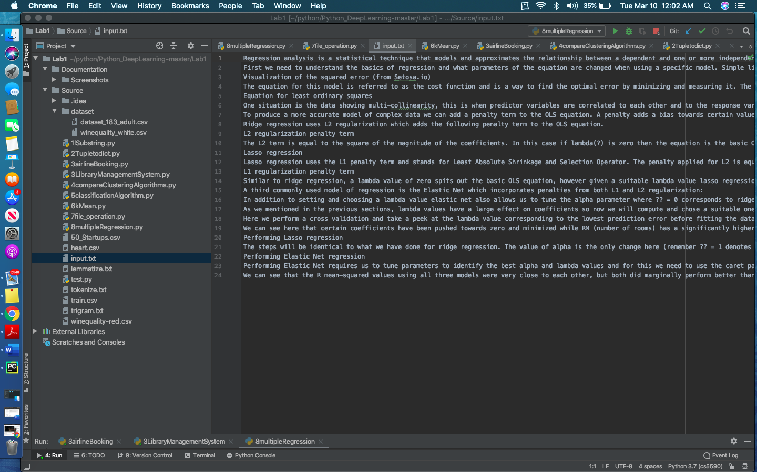

Tokenize Text:

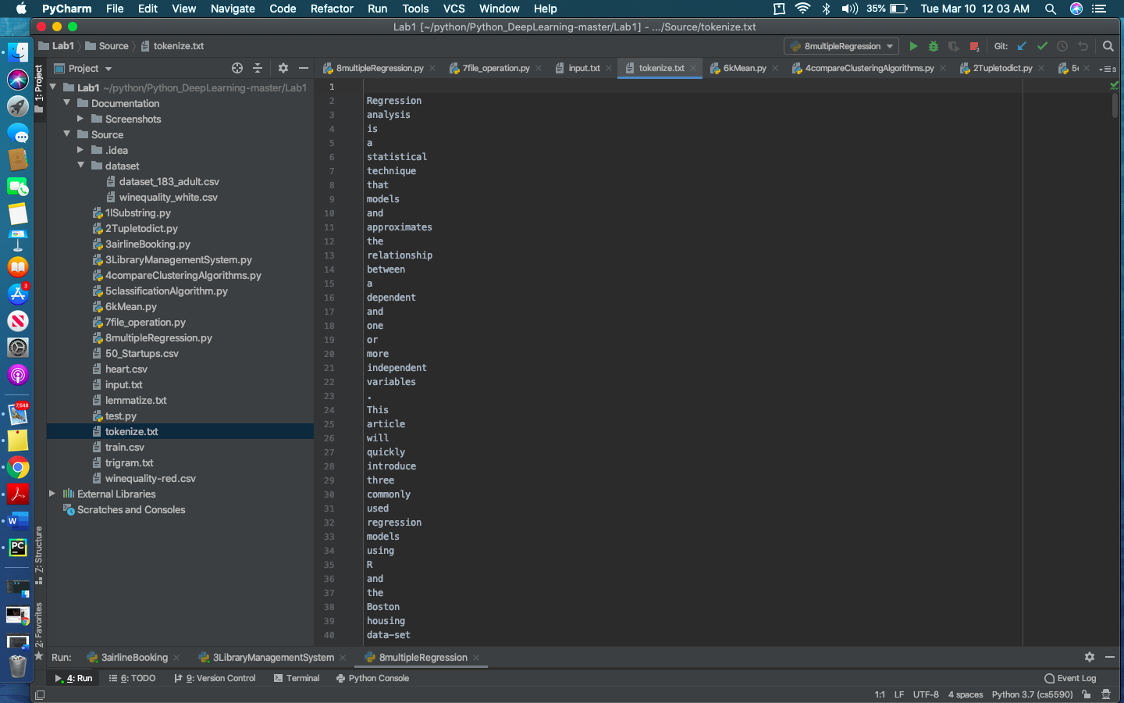

Trigram Text:

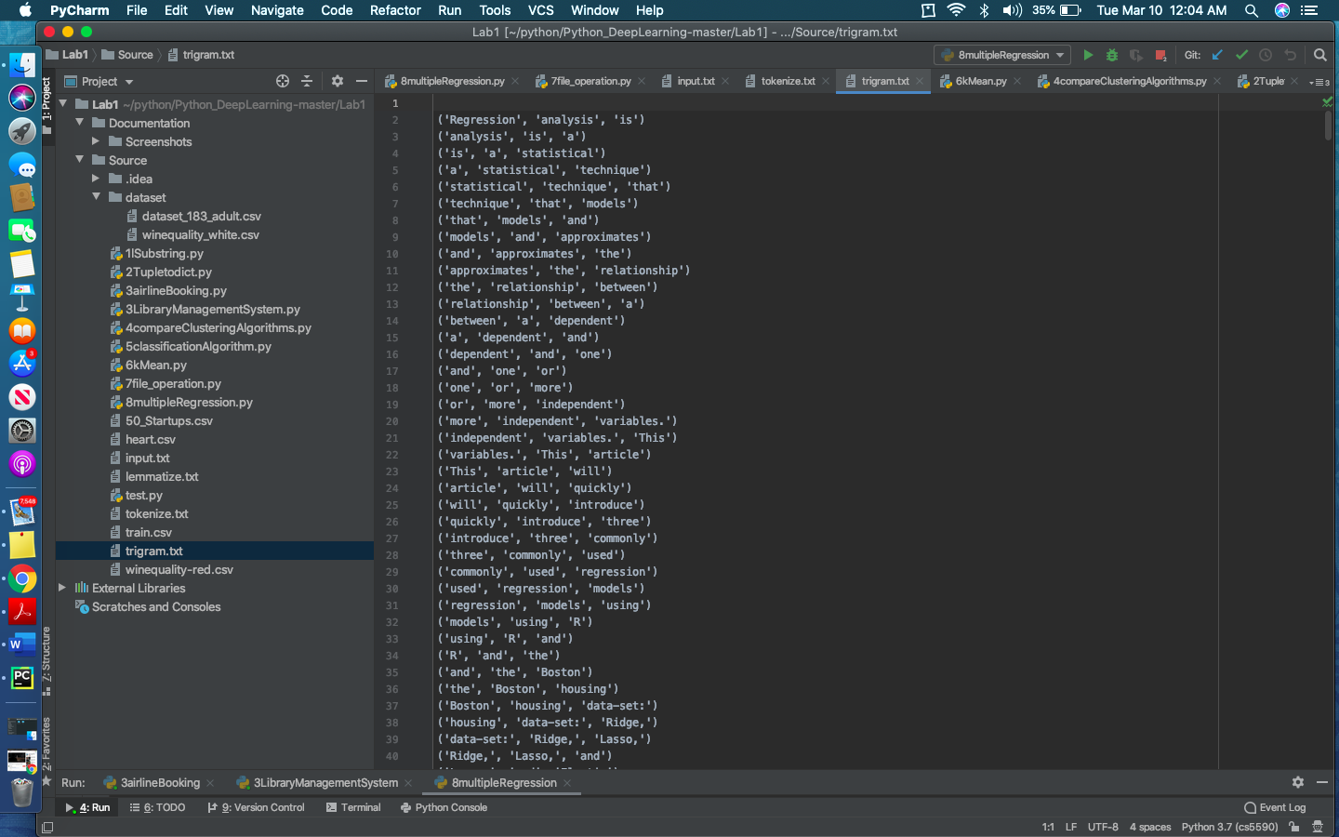

Top 10 Trigrams:

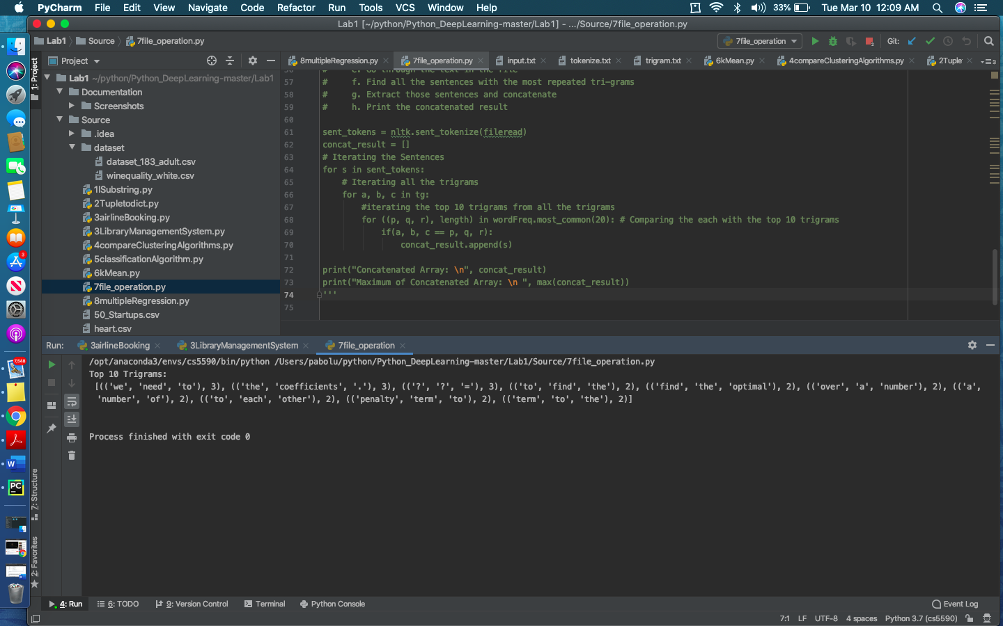

Concatenated Strings:

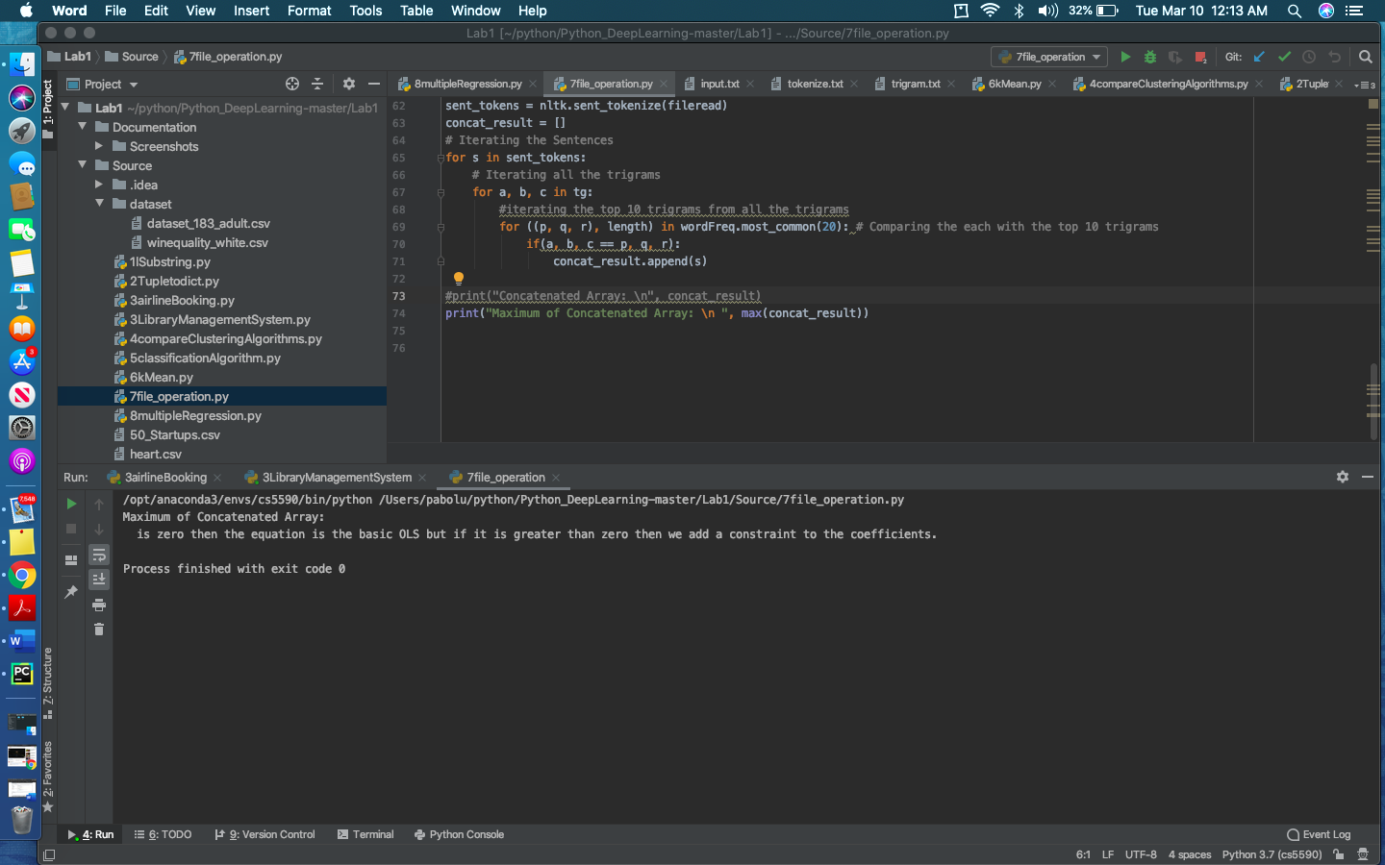

**8. Create Multiple Regression by choosing a dataset of your choice. Evaluate the model using RMSE and R2.**

**Course of Action:**

1. Heart dataset from Kaggle is taken as an input file.
2. Ensured to Handle the null values.
3. Be sure to remove the Missing values, So that you can get most relevant features.
4. The data information is preprocessed.
5. Now calculate the RMSE and R^2 scores on the preprocessed data.

**Code Snapshot:**

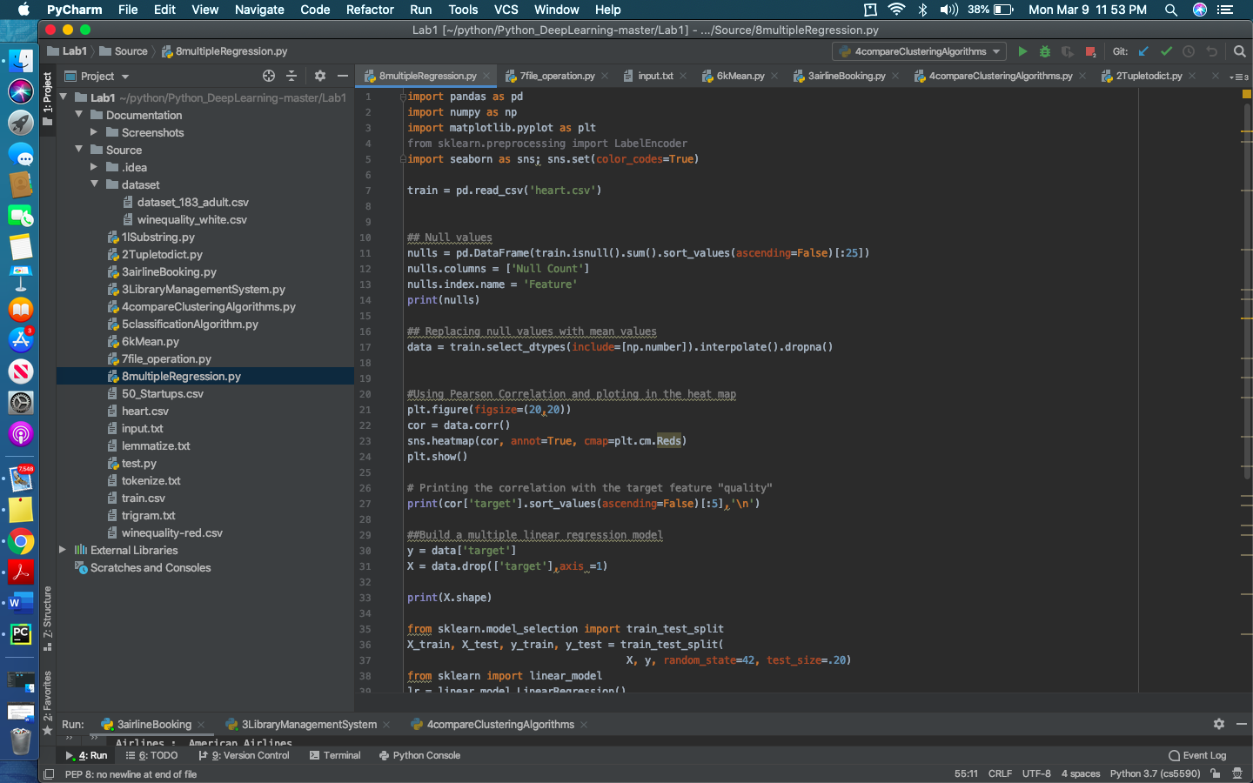

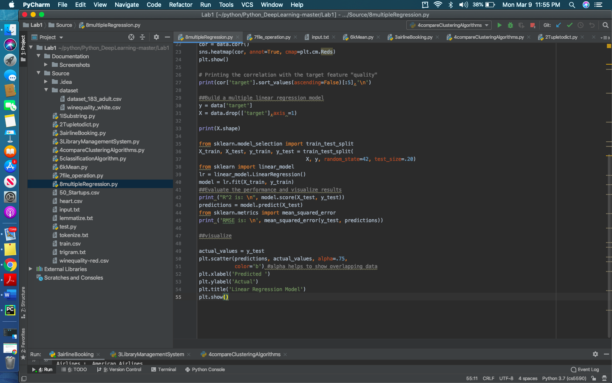

**Endresult:**

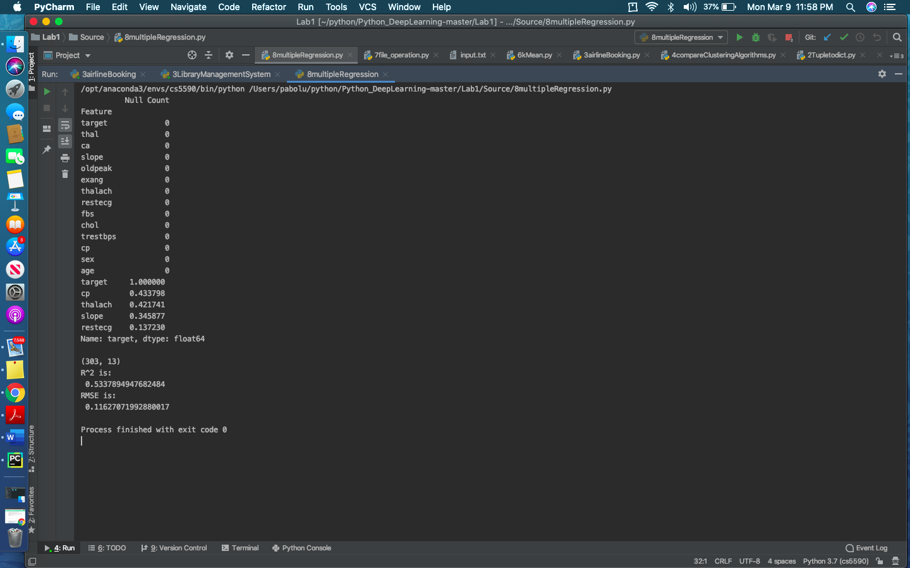

**CONCLUSION:**

We figured out how to apply profound learning ideas and calculations to draw lovely experiences from information and anticipate the yield. By playing out all the assignments we got hands on understanding on Python and Machine learning ideas.

**Video:**